GlobalSiege β1
Battle Guide

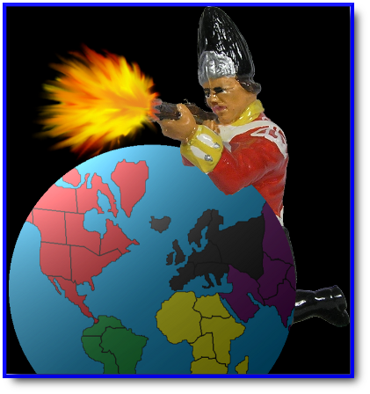

Intro 4
GlobalSiege 4
GlobalSiege Features 4
Download and Install GlobalSiege 4
Boot Camp – a quick start guide 5
Set up a new war 5
Place new units 6
Attack the enemy 6
Move, fortify and end your turn 7
Trade cards 8
Conclusion 9
GlobalSiege Setup 10
Battle tab 10
Missions tab 11
Dice tab 12
Cards tab 13
The Art of War in GlobalSiege 15
Declare war 15
The Info box 15
The tools of battle 15
Deploy new units 16
Attack 16
Overrun 17
Retreat 17
Move and fortify 18
Pass to end your turn 18
Dice 19
Dice Rules 19
No dice 19
Sorted Dice 19
Unsorted Dice 19
Draws 21
All Same Dice Thrown 21
Attack Probabilities 21
Cards 22
Valid sets 22
Fixed card values 22
Increasing card values 23
Countries 24
Continents 24
Missions 24
End of wars stats 25
Networking 26
Setup 26
Options 26
Settings 26
Host Options 26
Connections 26
IP Config 26
Host a LAN war 26
Join a LAN war 26
Host an Internet war 27
Join an Internet war 27
Chat 27
Vote 27
Auditing 27
The Counter 27
Credits 28

Intro

Welcome to the GlobalSiege Battle Guide, an instruction manual for GlobalSiege. This battle guide has two major Sections. The first section, the Boot Camp is a basic step by step quick-start guide and should be completely read by new players. The rest of this guide should be treated as a reference manual and read at your leisure if at all.

** Please note that as of January 2011 this document is far from complete and has many sections, such as the networking section completely missing.

GlobalSiege

The object of the game of GlobalSiege is to capture every territory on the board and wipe out all of your opponents’ forces, or to complete a secret mission issued at the start of the war. You can wage war in GlobalSiege with up to 6 players, either human or computer controlled. Wars can be fought across a local area network, across the Internet or by using the hot seat method on a single terminal.

GlobalSiege Features

- GlobalSiege is highly configurable allowing you to customize your wars to your own battle requirements. You can set GlobalSiege up to emulate Parker Brother’s Risk or you can make up your own rules and create your own original war game.
- A clean and uncluttered battle display that can be resized to suite your preferences.
- Tight Internet security achieved through encryption.
- An auditing system to prevent cheating when battling over the Internet.
- An automatic connection announcement set by the host which is displayed to terminals when they connect.
- A voting system to allow remote terminals to force turns to be forfeited and to kick nuisance players from an Internet session.
- Cards are pre-selected when you are forced to trade or when the cards across the top are clicked.
- The Info Box will flash when it is your turn. This can be turned off from the Options menu if you find it annoying.
- Ongoing development ensures that bugs and undocumented features fixed quickly.

Download and Install GlobalSiege

You can download GlobalSiege from http://www.globalsiege.org. Open the zip file and run setup.exe. **todo More details.

Boot Camp – a quick start guide

This section, the Boot Camp, will help you quickly get started waging wars in GlobalSiege without the need to read this whole document.

Wars in GlobalSiege are made up of the following steps:

- Set up and declare war
- Place new units
- Attack the enemy
- Move, fortify and end your turn
- Trade cards

Set up a new war

After starting GlobalSiege, the first screen that you will see is the setup screen. The default settings start the war with 1 human player (you) and 5 computer players.

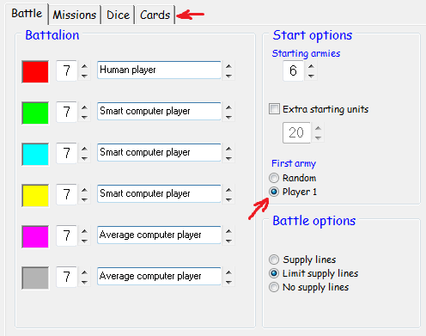
Figure 1 – configuring the Setup Screen

Click the Cards tab at the top of the set up screen. If Hidden is checked, uncheck it by clicking it with the left mouse button. This will enable you to see your opponent’s cards.

Go to the Battle and choose Player 1 as the First army. This will enable you, Player 1 to have the first turn.

Now click the Declare War button on the bottom right corner of the Setup screen. The Battle Map will appear. Countries will be randomly distributed in such a way that no one has an unfair advantage on their first turn.

Place new units

The Information Box will flash and read “The Red Army. You have 3 units to place. <Click destination country>“. This means that it is your turn and you have three new units to deploy. Select a red country and click on it 3 times with the left mouse button. You can spread your new units across any number of countries that you own but for this demonstration, we will deploy them all on one country.

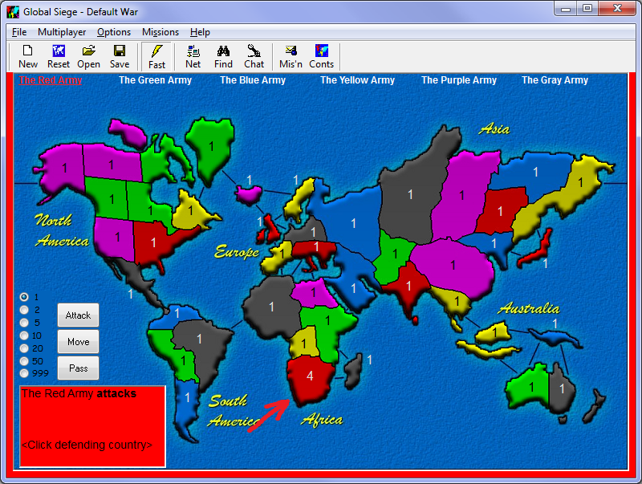
Figure 2 - placing new units on the Battle Map

When you have finished placing your units, the Info Box will read “The Red Army attacks <Click defending country>”. You are now ready for battle.

Attack the enemy

The Info Box will read “The Red Army attacks <Click defending country> “. Pick a country to Attack (the defending country) and click it with the left mouse button. It needs to be on a border with the country in which you placed the three units (the attacking country) and it can’t be a red country because you can’t attack your own territories.

The Info Box will now read “The red army attacks country with <Click attacking country(s)>“. You need to pick up units to attack with. Left click on the attacking country 3 times to pick up all of your units (the country you placed those 3 units in during the previous step).

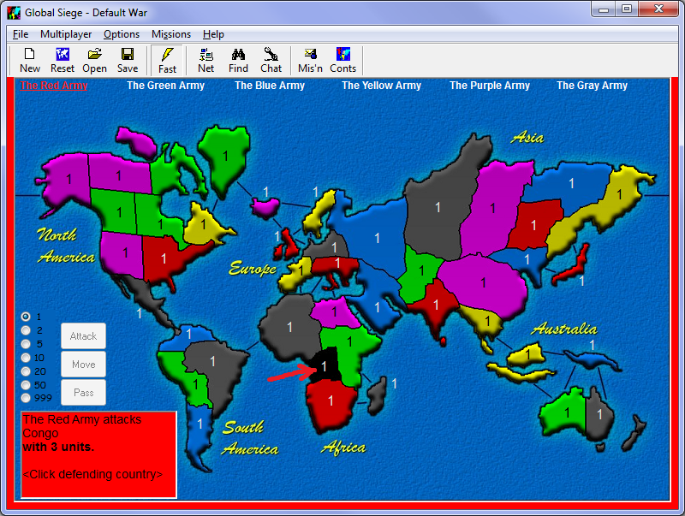
Figure 3 - your first battle

Now left click on the defending country. You will see two sets of dice rolled. The success of the attack depends on the outcome of these dice. If your attack was successful, your surviving units will occupy country. If your attack was beaten, try again. You can keep attacking until you run out of units or you can retreat by clicking on the attacking (your) country.

Move, fortify and end your turn

If you have any units remaining, you can move them to neighboring countries that you hold or you can pass by clicking the Pass button.

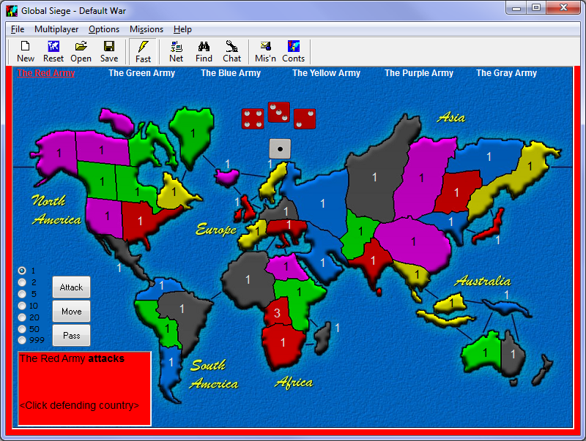
Figure 4 - your first battle victory

When you pass, if you had made a successful attack during your turn, you will be dealt a card. Only one card is dealt per turn, no matter how many countries you defeated.

The other players will now have their turn. Once they have finished, it’s your turn again.

Trade cards

At the start of your next turn, if you were awarded a card you will see it on the board between South Africa and Western Australia. After a few turns you will have a set of cards.

To trade your cards, first select a valid set by clicking on three cards. An Exchange and Cancel button will appear. If you click the small cards at the top of the screen or near the main cards, a valid set will be selected for you if a valid set exists.

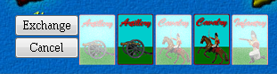
Figure 5 - exchanging cards

Press the Exchange button. If you don’t have a valid set, you will be ignored. Otherwise a dialog box will appear telling you how many units the cards are worth.

Press OK and you are ready to deploy your new units and the extra units from trading cards.

Conclusion

This ends the first section of the GlobalSiege Battle Guide. You should now be able to start a war and battle the computer players. When you have mastered the art of battle, your next step is to begin battling against real human players by joining the GlobalSiege network community. The rest of this document is the GlobalSiege reference manual describing all the GlobalSiege functions and options in detail. May all your victories be glorious.

GlobalSiege Setup

After starting GlobalSiege, the first screen that you will see is the tabbed Setup screen.

Battle tab

- Battalion Allocator. Starting countries allocated to each battalion and who controls each battalion.
- Start Options. The number of starting battalions, distribute extra starting units to each player at the start of the war and the player to have the first turn.
- Battle options. Supply lines determine how many units can be moved after finishing attacking your opponents.

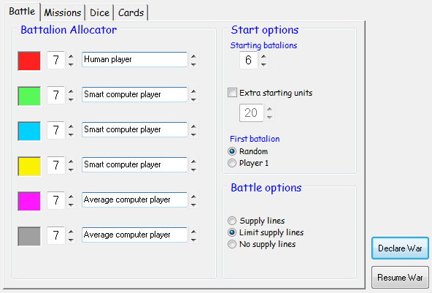

The number displayed next to the players’ color is the number of countries that the player starts with. There are 42 countries on the map so the total of the starting countries for all players must add up to 42.

If you want less than 6 players in a war, you can reduce the starting countries of the players that you don’t want to 0. You must then increase the starting countries for the remaining players so that the total number of starting countries adds up to 42.

The box to the right of the starting countries selects who controls that army. There are four choices to select from.

- Smart computer player. Controlled by the computer.
- Average computer player. controlled by the computer
- Unclaimed. Controlled by the computer and available to be taken over by a remote terminal if networked.
- Human player. Controlled by the operator of this terminal, that’s you.

Missions tab

- Missions. Turn Missions on or off.
- Army wipeout. Only army wipeout missions are assigned.
- Conquer and hold. Only continent conquer and hold missions are assigned.
- Must complete your own mission. You do not win if another player kills your target army, instead your mission changes to occupying any 18 countries.
- Win immediately upon completion. When selected, you win immediately your target army is wiped out. When unselected, you need to wait until the start of your next turn after wiping out your target army before you win.
- Missions are unique. Only applies to conquer and hold missions. Two players could have the same mission if unselected.
- Mission list. Display all missions available determined by the various mission options.

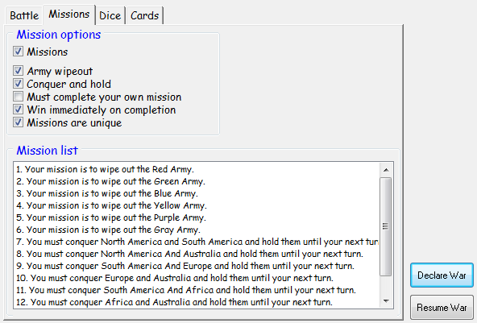

Dice tab

- No dice. No dice are thrown; instead battles are determined on a one for one basis. The combatant with the most units will win and the remaining units occupy the defeated country.
- Attacker wins draw. If two dice being compared are the same, the attacker wins.
- Defender wins draw. If two dice being compared are the same, the defender wins.
- Both retreat when draw. If two dice being compared are the same, neither the attacker nor defender win, and no units are lost.
- Both lose when draw. If two dice being compared are the same, both the attacker and defender loose one unit.
- Sort dice before battle. If checked, attack and defense dice are thrown then sorted with the highest to the left before comparing. If unsorted, the dice are not sorted before comparing.
- All Same Dice Thrown. If an attacker or defender throw all the same dice.
  - No difference. Dice are compared as normal.
  - Win battle. The player who throws all the same dice instantly wins that throw.
  - Lose battle. The player who throws all the same dice instantly looses that throw.
- Number Thrown. The maximum number of attack and defense dice thrown.
- Attack Probability. Reports the probability of winning an attack with the selected dice settings. The probabilities are calculated with the maximum dice the attacker and defender can throw. So if the attacker can throw up to four dice and the defender can throw up to three dice, the odds are calculated with four versus three dice.

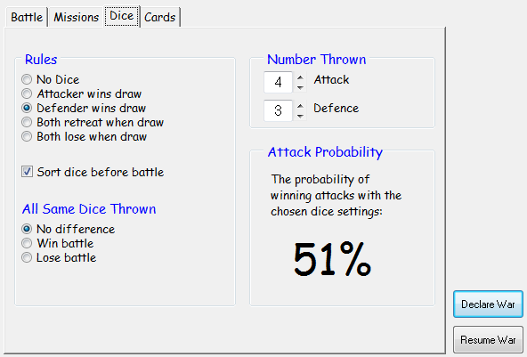

Cards tab

- None. No cards are dealt.
- Fixed. Card values are fixed with values determined in the Fixed Values box.
- Increasing. Card values increase with every set turned in until reaching the maximum value.
- Maximum. The maximum value increasing cards can reach.
- Hidden. Cards are turned over and hidden from other players.
- Capture. Player acquires cards from another player that they wipe out.
- The Deck. The number of each card type in the deck.
- Fixed Values. The value of sets turned in.

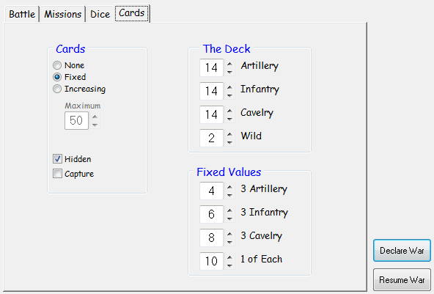

The Art of War in GlobalSiege

War in GlobalSiege involves a series of battles where players attack each other with the goal of taking a strategic advantage. After declaring war, individual battles involve four main processes.

- Strategically deploy your new units.
- Attack the enemy with the goal of taking some of advantage.
- Strategically move and fortify your territories.
- Survive the enemy’s attack and possible retaliation.

The outcome of each attack is decided by the attacker and defender each rolling dice. The number of dice thrown by the attacker and defender depends on the number of units involved in the attack and the number of dice selected in the setup screen. Combatants can throw a maximum of one dice for each unit involved in the attack not exceeding the maximum selected on the setup screen.

Declare war

After setting up a new war in the Setup Screen, click the Declare War button to the bottom right of the Setup screen. The Battle Map will show and countries will be randomly allocated to each player.

The Info box

The Info Box located on the bottom left corner of the Battle Map keeps human players updated on the current war. The upper part of the Info Box headlines events in the war. The lower part tells you which countries to click during the Place, Attack and Move sequences. The background color of the Info Box is the same as the color of the current player.

Watch the Info Box during your turn. It will help you through the different sequences, tell you when you need to change cards and generally let you know what is happening and what you need to do.

The tools of battle

The Attack, Move and Pass buttons can be found on the Battle Map directly above the Info Box. To the left are the Transfer buttons.

The Attack button is used to launch an attack. GlobalSiege will automatically put you in the Attack mode whenever possible so there is no real reason to click the attack button unless you have become confused.

The Move button is used to move your units between countries after you have finished attacking your enemies. Once you press the Move button you can no longer attack until your next turn.

The Pass button is used to end your turn.

The Transfer buttons control how many units are picked up or transferred for each mouse click.

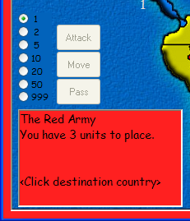

Deploy new units

At the start of your turn, you are given new units to deploy. The number of units you receive depends on how many countries you own and which continents you hold.

To place your new units, left click the destination country. The destination country is any country that you own. You can deploy all of your units on one country to launch an attack or you can spread them around to fortify and defend territories that you own.

You are now ready to Attack, Move or Pass.

Attack

After strategically deploying the last of your new units, you are automatically put into the attack sequence. The first step in the attack sequence is to pick a country to attack (the defending country). You can only attack a country that shares a border with one of your own countries or has a connecting line between the two, and the attacking country that you own needs to have two or more units to attack with. The country that you are attacking will turn black after you click it.

The next step is to pick up units from your own country by clicking on the attacking country (or countries; you can attack from as many countries as you like). Pick up as many units that you feel you will need. You can change the transfer rate by clicking one of the numbers in the Transfer Box to the far left of the Battle Map.

You can now begin your attack. Click the defending country again. The dice will roll to determine the success of the attack. You can keep attacking until you either win or run out of attacking units. Double clicking the defending country will overrun that country, where your units will automatically keep attacking.

You can retreat from the attack at any time by clicking one of your own countries.

If you win a battle, the surviving attacking units will occupy the defeated country. If you have enough units remaining, you can launch another attack from your newly acquired country or you can move or pass.

If you wipe out the last country owned by another player and if the Capture Cards option was selected in the Cards tab during setup, you will receive all cards that your victim owns, and you can trade them immediately if you have a valid set.

If you get confused at any stage during the attack, press the Attack button to reset the sequence. If you have picked up any units (check the Info Box), you will need to put them back into the country from which they came before the Attack and Move buttons will become active again.

Keep an eye on the Info Box for guidance.

Overrun

During an attack you can double-click the defending country to overrun that country. While over running a country, you can stop the overrun by clicking on the defending country again. You can then choose to either continue the attack or retreat your units.

Retreat

If your attack is going badly and the dice are not falling in your favor, you can choose to retreat your attacking units by clicking on your attacking country or any country that you own on a border with the defending country.

Move and fortify

After you have finished your attacks, you should move your units to fortify and defend continents.

If the Limit supply lines or No supply lines options were selected during setup then you are restricted to moving only a short distance:

- Supply lines. You can move your units between adjoining countries that you own without any restrictions
- Limit supply lines. You are limited in the distance that you can move your units.
- No supply lines. You can only move once.

To move, click the Move button. Next click the country you want to move to (the destination country). Now click the country you want to move from to start the transfer (the source country). Keep clicking the source country until you have moved enough units. You can change the transfer rate using the Transfer buttons. You need to leave at least one unit on each country that you own.

When you have moved enough units, click the destination country to stop the move. You can begin another move by selecting another destination country. There is no need to press the Move button again unless you become confused. Press the Pass button when you have finished moving.

If you get confused at any stage, press the Move button again to reset the move sequence.

Keep an eye on the Info Box for guidance.

Note that once you have pressed the Move button, you can no longer attack until your next turn.

Pass to end your turn

When you have finished your turn, press the Pass button. If you have made a successful attack during your turn, you will be dealt a card. You only receive one card no matter how many countries you defeated during your turn.

You need to replace all picked up units to where they came from before the Pass button will become active.

Dice

The outcome of an attack is determined by the attacker and defender each rolling dice. The number of dice thrown by the attacker and defender depends on the number of units involved in the attack and the number of dice selected in the Dice tab of the Setup Screen. Combatants can throw a maximum of one dice for each unit involved in the attack not exceeding the maximums selected on the Setup Screen.

The dice are displayed with the attack dice across the top usually in an arc and the defense dice underneath. If the dice are sorted, the dice will be displayed with the highest dice to the left.

Dice Rules

GlobalSiege is designed to be highly configurable allowing the players to design their own rules for dice. Players can select up to five attack dice and up to five defense dice. They can decide what happens with drawn dice (attack and corresponding defense dice are the same), if the dice are sorted before comparing them and what happens when all the same dice are thrown by the attacker or defender.

No dice

No dice are thrown; instead battles are determined on a one for one basis. The combatant with the most units will win and the remaining units occupy the defeated country. If the number of units defending a territory is attacked with the same number of units, the defender wins with one unit left in the defending territory. For example, if a territory with one unit is attacked with one unit, the attacker looses that unit and the defender keeps the territory with one unit remaining.

Sorted Dice

Attack and defense dice are thrown then sorted with the highest to the left. The highest attack die is compared to the highest defense die according to the rules selected in the setup screen. The owner of the defeated die looses one unit. The next highest attack die is then compared with the next highest defense die. This continues until the attacker or defender run out of dice to compare.

Dice are rolled again to continue the battle by again clicking on the defending territory, or the attacker can retreat by clicking on the attacking territory.

Unsorted Dice

Attack dice and defense dice are compared without being sorted. The attack die on the far the left is compared with the defense die on the far left according to the rules selected in the setup screen. The loosing die is removed from the battle and the owner of the loosing die looses one unit. The remaining attack die to the far left is then compared with the remaining defense die to the far left. This continues until either the attacker or defender run out of dice to compare. If the dice being compared are the same and the user has selected to retreat on draw in the Setup Screen, both dice are eliminated however neither party looses any units.

Dice are rolled again to continue the battle by again clicking on the defending territory, or the attacker can retreat by clicking on the attacking territory.

As a demonstration, if three attack dice and three defense dice were rolled as in the table below;

Attack dice | 5 | 4 | 3
Defense dice | 2 | 5 | 1

The first attack die is compared with the first defense die. The loosing die, in this case the defense die is eliminated and the defender looses one unit.

Attack dice | 5 | 4 | 3
Defense dice | 2 | 5 | 1

The winning attack die is now compared with the next defending die. The dice are both the same meaning a draw. In this case, assume that the defender wins the draw which means the attacker’s die is eliminated and the attacker looses one unit.

Attack dice | 5 | 4 | 3
Defense dice | 2 | 5 | 1

The next attack die is compared with the next defending die. The defender wins again. The attacker looses another die and another unit.

Attack dice | 5 | 4 | 3
Defense dice | 3 | 5 | 1

The next attack die is compared with the winning defense die and wins again. The attacker looses another die and one more unit.

Attack dice | 5 | 4 | 3
Defense dice | 2 | 5 | 1

The last attack die is compared with the winning defense die and again looses the die and one more unit. The attack has finished because the attacker has run out of dice. The attacker has lost three units and the defender has only lost one. If the same set of dice were compared after sorting, the attacker would have lost one unit and the defender would have lost three.

Draws

Draws happen when two dice being compared during an attack are the same.

The following rule options are available for the user to set before the start of the war:
- Attacker wins the draw giving the advantage to the attacker during battle.
- Defender wins the draw giving the advantage to the defender during battle.
- Both retreat with neither side loosing any units. If dice are not sorted, the drawn dice are eliminated but neither party looses any units.
- Both loose with the loss on one unit each. If both have run out of units, there must be at least one unit occupying a territory in which case the defender keeps the territory.

All Same Dice Thrown

When all attack dice or all defense dice thrown are the same, the options available from the setup screen are:
- Ignore and carry on the attack regardless.
- Instantly win the battle costing no units with the opponent loosing all units in the attack.
- Instantly loose the battle loosing all units involved in the attack without costing any opponent units.

If both the attacker and defender throw all the same dice, the attack will be carried on regardless.

Attack Probabilities

The probability of winning an attack with the selected dice settings is displayed in Dice tab in the Setup screen. The probabilities are calculated with the maximum dice both the attacker and defender can throw. So if the attacker can throw up to four dice and the defender can throw up to three dice, the odds are calculated with four versus three dice. This does not quite reflect the odds of a real battle because many battles use less dice as the attacker and defender run out of units.

Cards

At the end of every turn in which a player makes a successful attack, that player receives a card. When the player accumulates a valid set of cards, they can be traded for extra units.

To trade a set of cards for extra units, select the cards that make up the valid set by clicking them individually. If the cards are hidden, click any card to turn them all over. If you click near the cards or if you click the cards across the top of the Battle Map, a valid set will be automatically selected for you if one exists. An Exchange and a Cancel button will appear next to the cards.

Click the Exchange button and if you have selected a valid set, a message box will appear telling you what their value is. Click the OK button and your new units will be ready for deployment.

Cards can be exchanged at any stage during your turn. The value of the cards depends on whether the card values were set to Fixed or Increasing before the start if the war.

Valid sets

A valid set of cards is made up of either three of the same type of card or one of each type.

By default there are 14 Artillery, 14 Infantry, 14 Cavalry and 2 Wildcards in the deck however this can be changed in the Cards tab in the Setup Screen. Wildcards substitute for any of the three other types of cards to make a valid set.

Fixed card values

The value of the cards does not change during the war. The following table lists the default values of valid card combinations however this can be changed in the Cards tab in the Setup Screen. These values can be changed in the Cards tab of the Setup Screen.

- 3 Artillery = 4 units.
- 3 Infantry = 6 units.
- 3 Cavalry = 8 units.
- 1 of each = 10 units.

During battle, clicking near the cards or clicking the cards across the top of the Battle Map will automatically select a valid set for you if one exists.

Increasing card values

All valid card combinations have the same trade value however their values change during the war. The first set traded in is worth 5 units. The next set is worth 7 then 9, 11, 13, etc. up to 25 units. The set after 25 is worth 30 then 35, 40, 45 etc. up to the maximum value set in the Cards tab of the Setup screen.

Countries

Countries are individual territories that make up continents. The more countries that a player holds at the beginning of their turn, the more new units they will receive. The formula is: (countries_owned / 8) + 3.

- 1 to 8 countries = 3 units.
- 9 to 16 countries = 4 units.
- 17 to 24 countries = 5 units etc.

You can attack Kamchatka (far east Siberia) from Alaska and Alaska from Kamchatka. Clicking the ocean next to Alaska is taken as clicking Kamchatka, and the ocean near Kamchatka is taken as Alaska.

Continents

There are 6 continents in the GlobalSiege world. Each is made up of a group of countries. If you hold a complete continent at the start of your turn, you will be issued with more units.

- South America is worth 3 units.
- Australia is worth 3 units (includes Indonesia).
- Africa is worth 4 units.
- North America is worth 6 units (includes Greenland).
- Europe is worth 6 units (includes Ukraine but not the Middle East).
- Asia is worth 8 units (includes Siam and the Middle East but not Ukraine).

Right clicking any country during a war will tell you which continent the clicked country belongs to.

From the menu bar select Help - Continent map or click the Conts menu item from the tool bar for a continent map.

Missions

If the Missions checkbox was checked in the Missions tab of the Setup screen, each player is dealt a secret mission when war is declared. You win the war if you complete your mission before any one else completes theirs.

You can change the type of missions dealt and the conditions for completing missions from the Missions tab in the Setup Screen.

To see your mission during the war, first make sure that other human players are looking away (the computer players will not peek), then go to the Missions dropdown menu and select See mission. Another way is to click Mis’n from the tool menu, or press control-M.

End of wars stats

Each player is given a score, which is based on the number of countries gained and lost, the number of units involved in the war (the fewer the better) and starting conditions. Winning a war doesn't particularly mean that you will have the highest score, it depends more on how well you fought your battles and how efficient you were with your units.

End of war stats can be turned on or off from Options – End of war stats dropdown menu.

Networking

GlobalSiege wars can be fought over a local area network (LAN) or over the Internet. You can have up to six participating terminals and up to sixteen observing terminals.

A network war has one host terminal that controls the war (does not have to be a participating terminal) and one or more client terminals that join the war. To connect, the selected host first listens for connection requests from clients. Clients then request a connection with the host. Once connected, players are assigned to terminals and war is declared.

**todo Version B1, January 2011, networking is not yet fully functioning.

Setup

Options

Settings

Host Options

Connections

IP Config

Host a LAN war

Join a LAN war

Host an Internet war

Join an Internet war

Chat

Vote

Auditing

The Counter

Credits

DEVELOPMENT
- Craig Douglas

PRE RELEASE TESTING AND ADVICE:
- Gary Wilson
- Gary Ryan

LANGUAGE TRANSLATIONS:
- Mauro Castelnuovo
- Lars Monsees
- Paolo Pelloni
- Gabriel A. Marturano
- Carl-Fredrik Bergdahl
- Gunnar Baardsen
- Walfroy Ract-madoux
- Simon Kofod

ARTWORK:
- Doug Burner
- John O'Brien (http://members.upnaway.com/~obees/soldiers/)

